Exercice 1
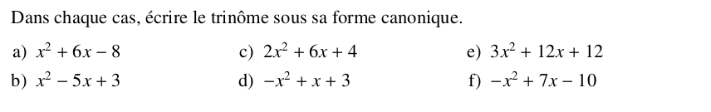
Exercice 2
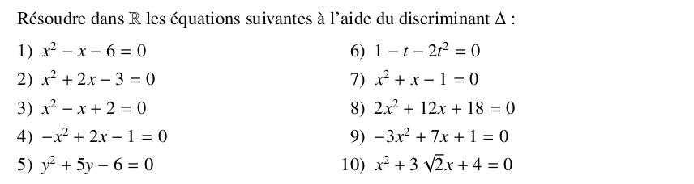
Exercice 3
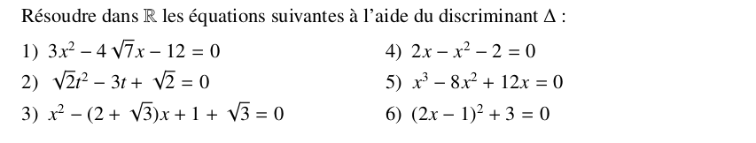
Exercice 4
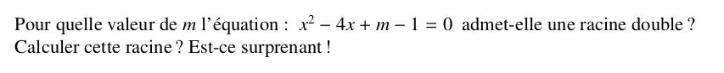
Exercice 5
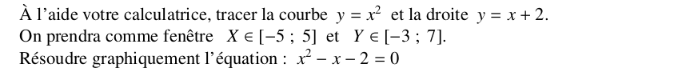
Exercice 6
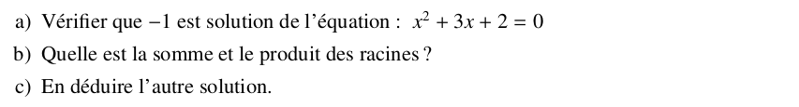
Exercice 7

Exercice 8
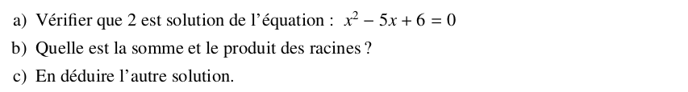

Exercice 9
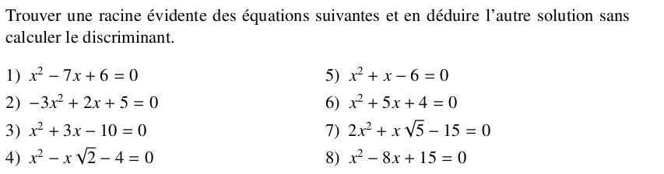
Exercice 10
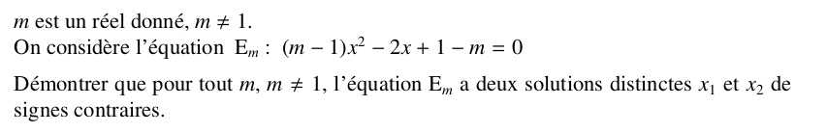
Exercice 11
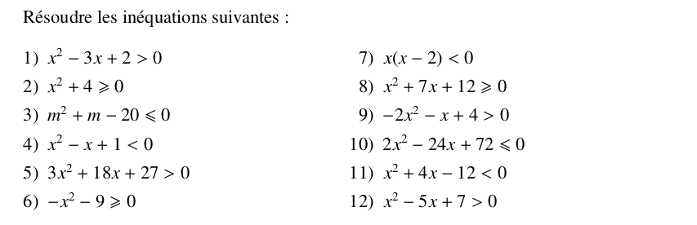
Exercice 12
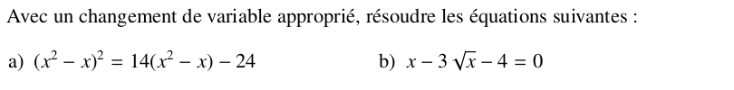

Exercice 13
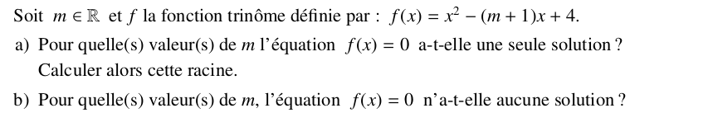
Exercice 14
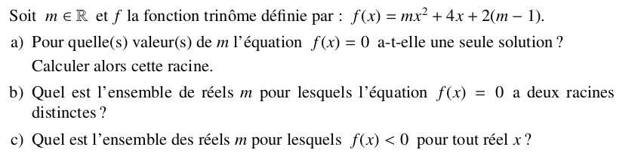
Exercice 15
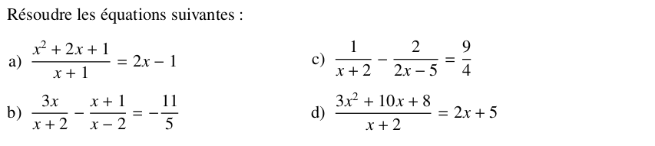
Exercice 16
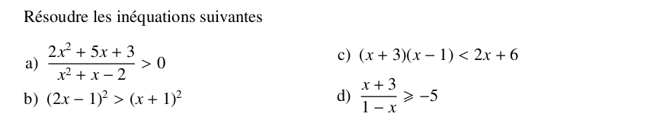
Exercice 17
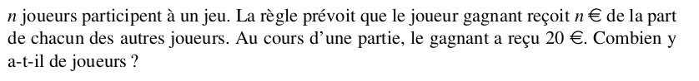

Exercice 18
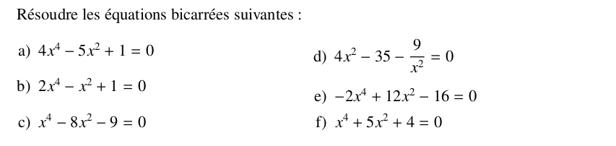

Exercice 19
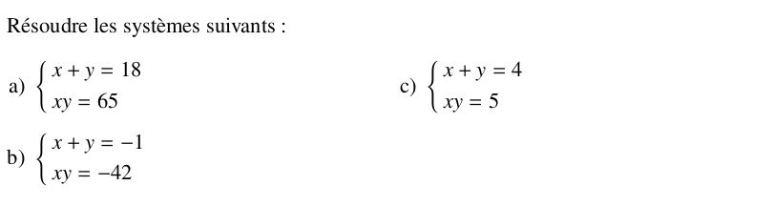

Exercice 20
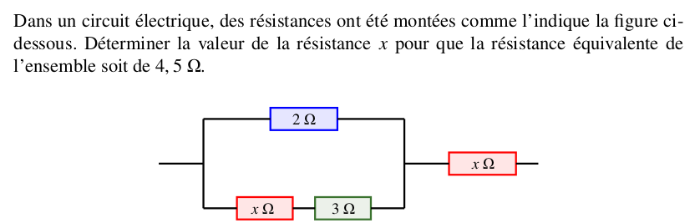

Exercice 21

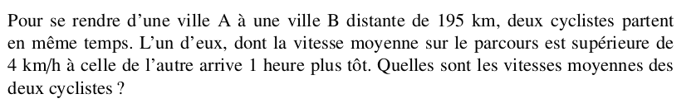

Exercice 22

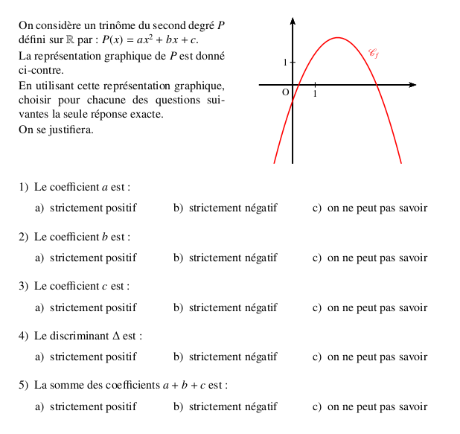
Exercice 23

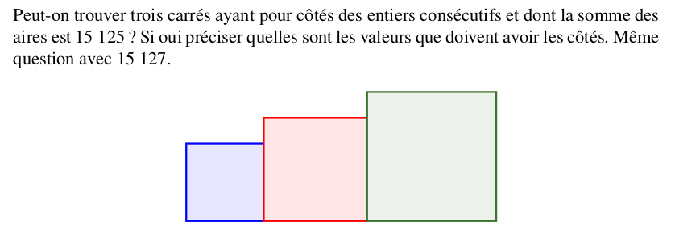

Exercice 24
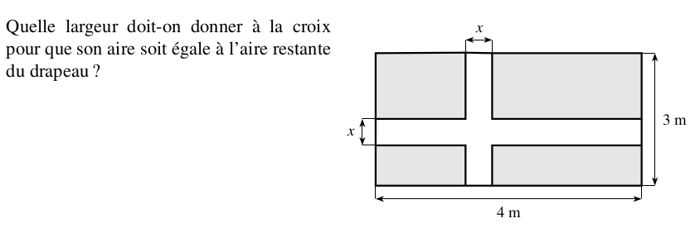

Exercice 25
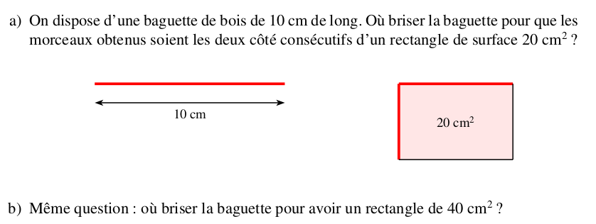

Exercice 26
